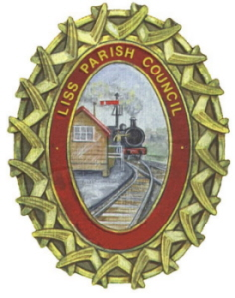
LISS PARISH COUNCIL
Interested in the future of Liss?
Liss Parish Council is looking for one or more new councillors
Councillors can contribute to our village development by:
- Commenting on planning applications to ensure consistency with the Liss Neighbourhood Plan
- Working with Hampshire County Council on traffic and road improvements
- Developing the use of existing parish facilities and working with the community on future priorities, including recreation facilities
Relevant knowledge and experience can be useful in the role, but enthusiasm, time to commit to the role and a ‘can do’ approach is even more important.

Tempted but not sure? Why not have a chat with the Parish Clerk or Assistant Clerk, or one of the councillors (details on our website).
Apply by 30th November 2021:
Please check your eligibility (www.lissparishcouncil.gov.uk – Your Council – How to become a Parish Councillor) and then send your reasons for applying along with a summary of your skills, experience, and expertise, a CV if you have one, as well as address and contact details, to the Clerk via email or post. A second vacancy may also be available and will be known prior to the deadline for applications. Informal interviews will take place early December. Liss Parish Council will consider candidates for ‘co-option’ at the Council meeting on Monday 13th December.

Sarah Smith, 09/11/21
clerk-smith@lissparishcouncil.gov.uk / 01730 892823
The Council Room, Village Hall, Hill Brow Road, Liss, Hampshire, GU33 7LA

A copy of this notice has been sent to the Returning Officer at East Hampshire District Council 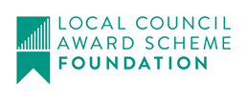 @LissCouncil

